Sample of visual analysis
I am including a sample of student writing below. This is an analysis of Corregio’s Virgin and Child with the Young Saint John the Baptist by Rachel Wang, 2015.
Note that your writing does not have to replicate this and would differ based on the object you select, your style of writing etc.

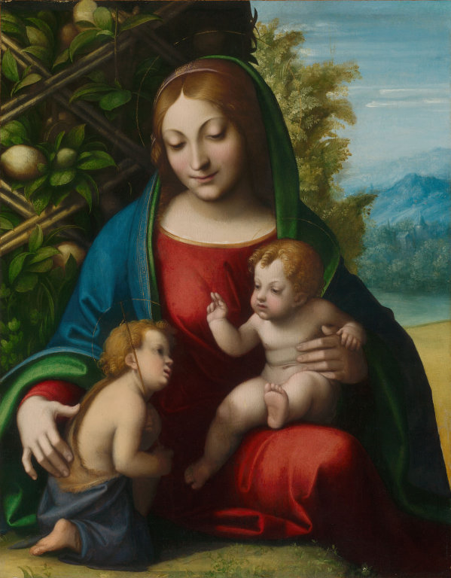

Correggio (Antonio Allegri)
Virgin and Child with the Young Saint John the Baptist , c. 1515
Oil on panel
25.25 × 19.75 in. (64.2 × 50.2 cm)
Virgin and Child with the Young Saint John the Baptist (c. 1515 AD) is an oil on panel painting by Italian artist Antonio Allegri, better known as Correggio, currently in the collection of the Art Institute of Chicago. This composition depicts the Virgin Mary holding Jesus and Saint John the Baptist as infants in a nurturing embrace, set against a lemon tree in an unknown landscape of forests and mountains.
The artist places the three figures at the center of the frame, in a balanced triangular composition with the matriarchal figure at the top, looking down at the two infants. The figures’ pose, in conjunction with the fairly symmetrical composition of the rest of the piece, constructs stability and imposes a sense of unity within the image. The trilateral placement of the figures suggests emotional intimacy among them. Correggio does not use distinct lines, but instead employs the shapes, colors, and values of the different elements in the painting to distinguish them from one other and render a more naturalistic scene. The positioning of objects within the artwork form polygonal shapes, like the rectangles that compose the middle ground and background, behind the triangular shape of the figures, assigning strength and stability to the composition. Additionally, the edge formed by the contrast between the yellow dirt and green grass generates a relatively wedge-like shape, enforcing the sense of firmness and even permanence. In contrast to the sharpness of the geometric forms in the background, the artist uses round and organic shapes to paint the figures. He therefore characterizes them with certain grace, poise, and intimacy, indicating the divinity of Mary, Jesus, and John the Baptist to the viewer. The gentle curves that he uses create a sensual, softening effect that balances out the otherwise fairly geometrical composition of the piece.
Correggio highlights the Virgin Mary by making the predominant color of her robes an orange-toned red. In setting this warm color against the infants’ pale flesh and soft pink flush of their cheeks, the artist brings life to the babies’ bodies—adding a greater sense of humanism to the otherwise pristine make-up of the figures. Because the figures are painted with much fairer and brighter colors than the background and middle ground, they appear to be lit under an unknown light source. Corregio’s use of chiaroscuro therefore allows the figures to stand out against the dark background, and gives the image an appearance of a glow emanating from his subjects’ bodies, further emphasising the holiness of the subjects. His use of smooth brushstrokes to paint the figures and the technique of sfumato to blend the tones results in an almost satin-like texture, evoking a feeling of wholesomeness within the figures. Although the consistent brushstroke quality of these foreground objects limits the amount of movement in the piece, it constructs a greater sense of harmony.
Correggio draws the viewer’s eye towards the middle ground object, a lemon tree that divides the panel space into two, to emphasize its symbolic presence of the fidelity of love and association with the Virgin Mary. The green foliage is painted with a deep, rich value, to show the intimate distance between the Madonna’s back and the wall of leaves and evoke the feeling of safety and security. Although the shrubbery is fairly dark, the lemon placed near the Virgin’s head is almost as bright as her skin, leading the audience to draw a connection between the emblematic fruit and her holy presence. The repetition of green in the foliage and in the accents of her clothing acts as a frame for the Virgin’s figure and connotes a sense of life and fecundity, imbibing a sense of comfort in the viewer.
The strong presence of the lemon tree is juxtaposed by the olive-colored tree and blue-hued mountains so that the image does not seem too heavily weighted on the left. These background elements contrast with the way the smooth rendering of the figures. The rougher brushstrokes that make up the mountainous and wooded background lack explicit precision and detail, creating a more textured, abstract, and vague depiction of the setting of the piece. The mountains are significantly smaller than everything else in the painting, suggesting a great distance between the wilderness and protection of the Virgin Mary’s arms. Correggio also draws further distinction between the background, middle ground, and foreground objects by making the background landscape the coolest area in the painting. In combination with a stylistically different painting technique, the use of cool, muted colors creates a serene feeling in the viewers for them to associate with the figures.
In this painting, Corregio depicts the familiar subject matter of the Virgin and Christ, and imparts it with a sense of the wholesomeness and holy unity through the use of visual techniques such as the muted tone, smooth brushwork and balance composition. These elements encourage an association of equilibrium with the sacred image, thus inducing a greater sense of harmony to the image.

Meagher, Jennifer. “Food and Drink in European Painting, 1400-1800.” Heilbrunn Timeline of Art History, the Metropolitan Museum of Art, 9 May 2020. https://www.metmuseum.org/toah/hd/food/hd_food.htm.

